Here is a basic manual for building a smart irrigation robot using Arduino:

**Materials Needed:**

* Arduino Uno
* Water pump
* Soil moisture sensor
* Servo SG90
* L293D Sheild
* 100 RPM Geared motor and wheels
* LI_ON Battery
* Charging module(TP4056)
* Ultrasonic sensor
* Prototyping jumper wires
* Wooden box
* Plastic container

**Step 1: Assemble the Hardware**

1.1 Take a wooden box attach mounting to connect geared motor and wheels at tn=he bottom using screw driver and screws.

1.2 Now attach 1 ultrasonic sensor connected with jumper wires then attach li-on batteries in the battery holder inside the wooden box

1.3 Place the plastic container adjust it according to your box size

1.4 Take a plastic rod and attach moisture sensor, pipe and 2nd ultrasonic sensor using hot glue so that it is moveable and go inside the plant check the moisture and ultrasonic sensor sense it need and water the plant if needed.

1.5 Also attach servo motor with them now attach the whole thing upside down to the wooden box keep in in view that pump pipe must be in downward position

1.6 Put water pump in the plastic container use lengthy wires for this purpose and connected it to the other end of moisture sensor all apparatus connected by using jumper wires.

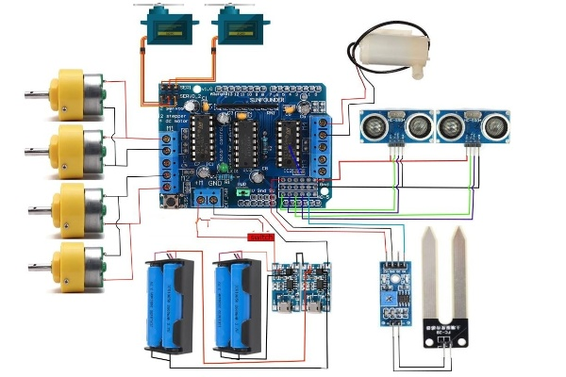

**Step 2: Upload the Code**

2.1 Download and install the Arduino IDE (Integrated Development Environment).

2.2 Copy and paste the following code into the Arduino IDE:

**Copy code**

#include <AFMotor.h>

#include<Servo.h>

Servo m1;

Servo m2;

int pos;

const int trigPin = A0;

const int echoPin = A1;

const int trigPin1=A2;

const int echoPin1=A3;

int mpin = A4;

int mout;

long duration, duration1;

int distance, distance1;

AF_DCMotor motor1(1, MOTOR12_1KHZ);

AF_DCMotor motor2(2, MOTOR12_1KHZ);

AF_DCMotor motor4(4, MOTOR12_1KHZ);

void setup() {

Serial.begin(9600);

pinMode(trigPin, OUTPUT);

pinMode(echoPin, INPUT);

pinMode(trigPin1, OUTPUT);

pinMode(echoPin1, INPUT);

m1.attach(10);

m2.attach(9);

m1.write(0);

m2.write(120);

motor1.setSpeed(255);

motor2.setSpeed(255);

}

void loop()

{

digitalWrite(trigPin, LOW);

delayMicroseconds(2);

digitalWrite(trigPin, HIGH);

delayMicroseconds(10);

digitalWrite(trigPin, LOW);

duration = pulseIn(echoPin, HIGH);

distance= duration*0.034/2;

digitalWrite(trigPin1, LOW);

delayMicroseconds(2);

digitalWrite(trigPin1, HIGH);

delayMicroseconds(10);

digitalWrite(trigPin1, LOW);

duration1 = pulseIn(echoPin1, HIGH);

distance1= duration1*0.034/2;

if (distance>=15)

{

Forward();

delay(100);

}

else if(distance<15)

{

Stop();

delay(70);

digitalWrite(trigPin1, LOW);

delayMicroseconds(2);

digitalWrite(trigPin1, HIGH);

delayMicroseconds(10);

digitalWrite(trigPin1, LOW);

duration1 = pulseIn(echoPin1, HIGH);

distance1= duration1*0.034/2;

if(distance1>=6)

{

servoF();

delay(100);

}

}

mout=analogRead(mpin);

if(distance1<6 && mout<=500)

{

servoB();

delay(100);

Forward();

delay(1000);

}

if(distance1<6 && mout>500)

{

while(mout>500)

{

motor4.run(FORWARD);

mout=analogRead(mpin);

if(mout<=500)

{

motor4.run(RELEASE);

delay(100);

break;

}

}

}

}

void Stop()

{

motor1.run(RELEASE);

motor2.run(RELEASE);

}

void Forward()

{

motor1.run(FORWARD);

motor2.run(FORWARD);

}

void servoF()

{

Serial.println("servo forward is fine");

delay(100);

for (pos=0;pos<=120;pos+=1)

{

digitalWrite(trigPin1, LOW);

delayMicroseconds(2);

digitalWrite(trigPin1, HIGH);

delayMicroseconds(10);

digitalWrite(trigPin1, LOW);

duration1 = pulseIn(echoPin1, HIGH);

distance1= duration1*0.034/2;

if(distance1>6)

{

m1.write(pos);

m2.write(120-pos);

}

}

}

void servoB()

{

Serial.println("Servo back is fine");

delay(100);

for(pos=120;pos>=0;pos-=1)

{

{

m1.write(pos);

m2.write(120-pos);

}

delay(30);

}

}

**2.3 Upload the code to the Arduino board.**

**Step 3: Test the Robot**

3.1 Turn on the power button.

3.2 Robot will start moving and automatically reaches the plant itself

3.3 Soil moisture sensor automatically gets into the soil of the plant you want to irrigate.

3.3 Wait for the soil moisture level to check then it automatically water the plant according to it need (set at 500 in the code).

3.4 The water pump should turn on and water the plant for the duration set in the code (set at 2 to 10 microsecond in the code).

3.5 Wait for the dry time set in the code (delay time)

3.6 Repeat steps 3.3 to 3.5 as necessary.

Note: Make sure to test the robot in a controlled environment before using it on your plants. Adjust the moisture threshold and pump duration in the code as necessary to suit your plant's needs